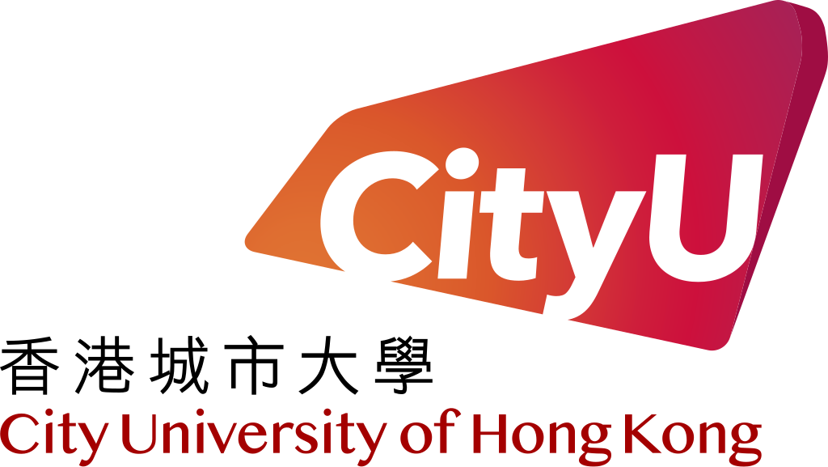

CS3343 Software Engineering Practice
Project Plan Report (Group 5)
Project Title: Sport Facility and Equipment Booking System

Name | Student Number
NG Ka Hung | 58533046
LIN Weiyuan | 58537684
LAU Wing Him | 58537137
IP Wing Kai | 58120400
LEE Kin Wai | 57925345
Chan Sing To | 58533974

Ng Ka Hung (58533046):
I learned Project planning and scheduling, team organizations, Version control and configuration management when being a Project Manager in this time. Besides I have learned how to use Junit5 library and types of software testing strategy to conduct auto testing of java program to ensure high quality.
Lau Wing Him (58537137):
In this group project, I learnt the most about the importance of clear communication and great teamwork. At the initial phase of the project, we argued and were unclear of how the program executed and its behavior, which leads to a bit of confusion when working. This is normal, as the program's requirements were not clearly defined yet. After we define the scope of the project and communicate clearly, we work well together.
Lin Weiyuan (58537684):
This project has given me a fantastic opportunity to develop my teamwork abilities. Our team split up the work so that everyone could contribute to crucial components like membership management and booking systems. We do meetings and code reviews every week, so this allows us to maintain consistency and address issues early. I learned the importance of clear communication and constructive feedback, which improved our workflow and the quality of our code. This experience also highlighted the importance of team collaboration in achieving our goal and has prepared me to work efficiently in future team-based projects.
Ip Wing Kai (58120400):
In this project, beside gaining a deeper understanding on what I have learned in school and in internship such as program design, project management, refactoring, test-plan design and vibe code with comment and copilot code auto-completion. This project provided me a chance to understand the challenges when we apply those knowledge into a teamworking project. For example, while WBS and Gantt chart provide a schedule of different high-level project components, when we integrate it with program design and coding, it is hard to strictly follow the schedule while unexpected dependency occurs. Although we are helpful, all of us are willing to separate a workload to meet the milestone in schedule, it further makes the work messy because of the unclear instruction.
Lee Kin Wai (57925345):
In this group project, it gives me a great chance to apply the skills and knowledges which learned from this course and my placement company. The importance of code refactoring, unit testing and groupmate communication have highlighted in this project. Also, I have leant a lot about AI assistance programming. In this AI age, we can not completely avoid using AI technology to enhance our productivity on daily work or study. Therefore, I obtained a ruch experience on using GenAI to assist on the code debugging, code refactoring and code advicing during this group project. To conclude, it is a great experience for me to apply and learn skills and knowledge in the IT industry.
Chan Sing To (58533974):
I learnt that testing is an important part of a project. In this project, although we have planned the approximate requirement and class structure in advance, we still have a chance to make mistakes when we consolidate each part of the functions. As a consequence, we need a variety of testing such as whitebox and blackbox testing. Due to the lack of testing, we confront many obstacles when we refactor our code.

